**The Paper Prototype of our Application:**

**Login Screen**

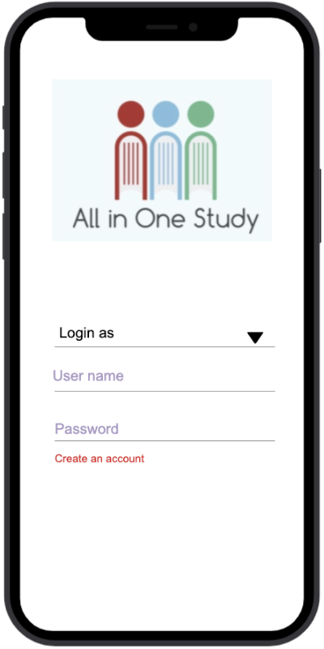

User guide to access the home page first:

STEP1: At login page, user has to enter the username that has already registered

STEP2: After entering the username, needs to enter the password that has already created at the time of registration

STEP3: Then, can access the other features of the application

STEP4: If new user wants to retrieve the application data, one has to create an account first

**Registration Screen**

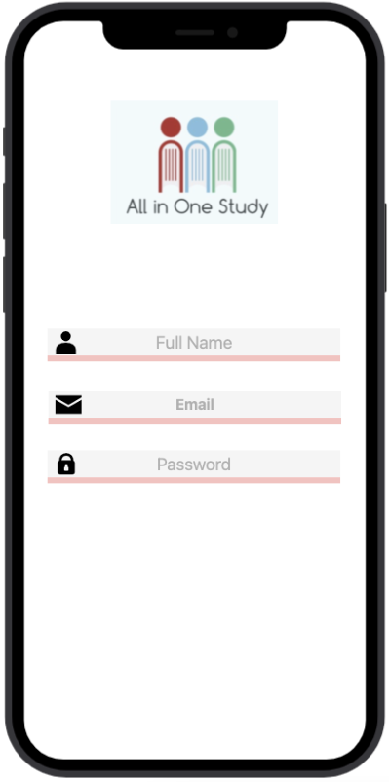

How can we register? Just follow the instructions below:

STEP1: Initially, user needs to enter first and last name

STEP2: Enter your given college email

STEP3: User has to create a password with one uppercase letter, one lowercase letter and a number, it has to be maximum 8-10 characters

STEP4: After the input of all required information, just click on the register button to access the application

**Student Home Screen**

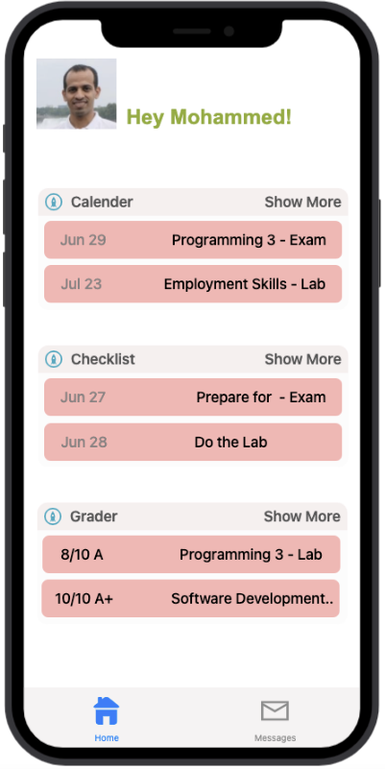

To access calendar, checklist and grades, please follow the given instructions:

STEP1: Just click on the calendar, and you will see the options of different subjects.

STEP2: Click on the checklist to create record for upcoming tasks.

STEP3: Click on grader button for checking all the grades.

**Student Calendar Screen**

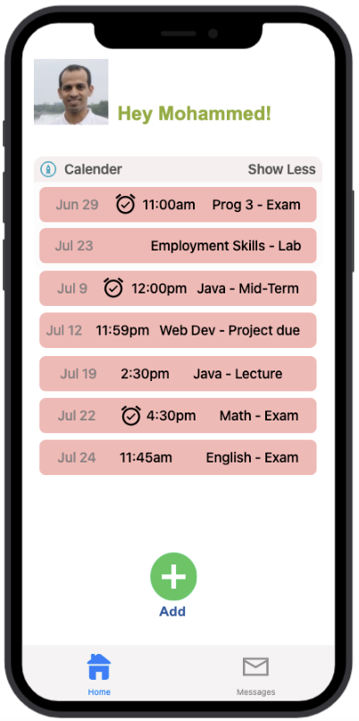

Follow the below steps to view whole calendar:

STEP1: Click on the calendar and you will see all upcoming tasks with schedule.

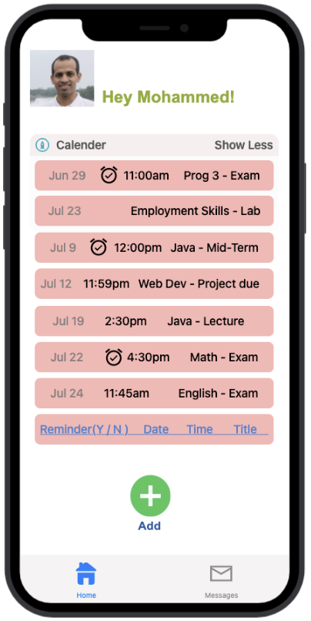

To set class schedule and configure the reminder, follow instruction that are given below:

STEP1: Click on the Calendar to see all further tasks to attempt.

STEP2: At last line, click on the reminder and select date, time and title for the upcoming project that needs to remind.

STEP3: Click on the Add to set reminder to get notification on scheduled time.

**Student Checklist Screen**

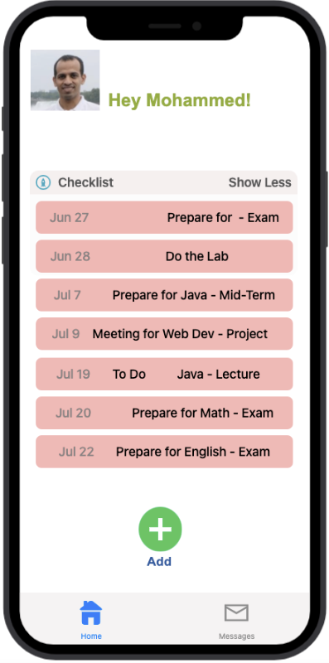

For making personal checklist, follow below instructions:

STEP1: To add upcoming tasks, just click on the add button and set time and title of the task.

STEP2: User can delete any task with delete option after clicking on the task.

STEP3: User can also include completed tasks in checklists.

**Student Grader Screen**

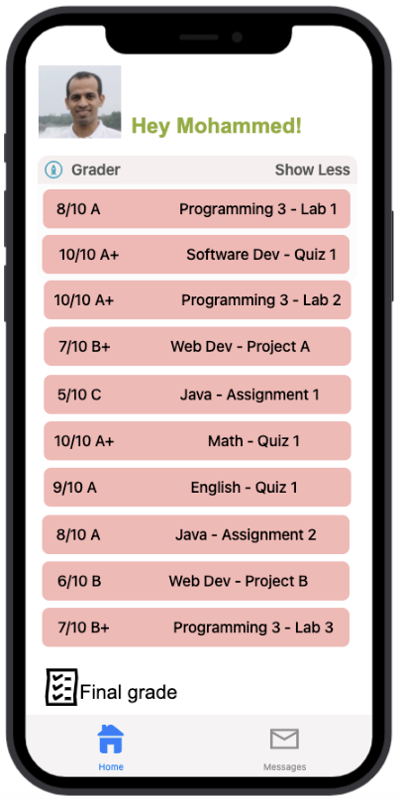

User can see grades by following just one step:

STEP1: Click on the grader option, and will see all the recent updated grades.

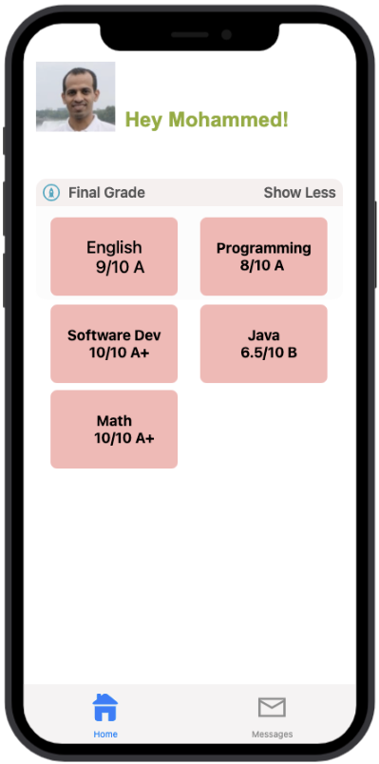

To see the completed grades, follow simple steps:

STEP1: Under the grader section, at last there is an option of Final grade.

STEP2: Click on the Final grade, then user can see the complete grades of every course separately.

**Instructor Home Screen:**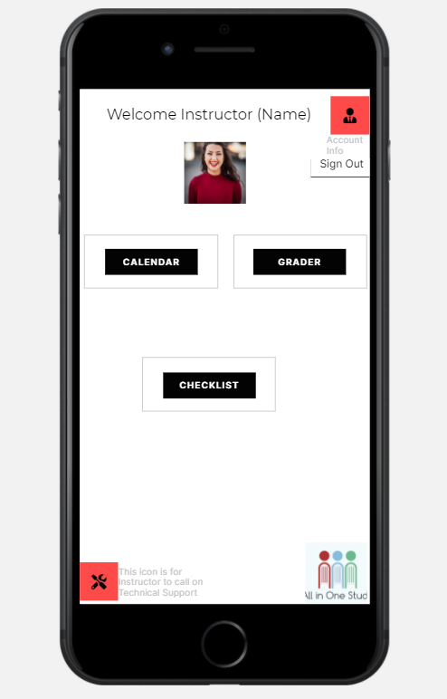

STEP 1: User has signed into the application and brought to the instructor’s main page where he or she can check at the academic calendar, grades, or the student checklist itself.

STEP 2: If the instructor faces any difficulty or problem or technical issue, they can select the Help option to submit a request to the IT department to resolve the issue concerning the app.

STEP 3: If the Instructor is done with their daily activities, they can choose to Sign out using SIGN OUT option to exit the application and be brought back to the login page.

**Instructor Calendar Screen:**

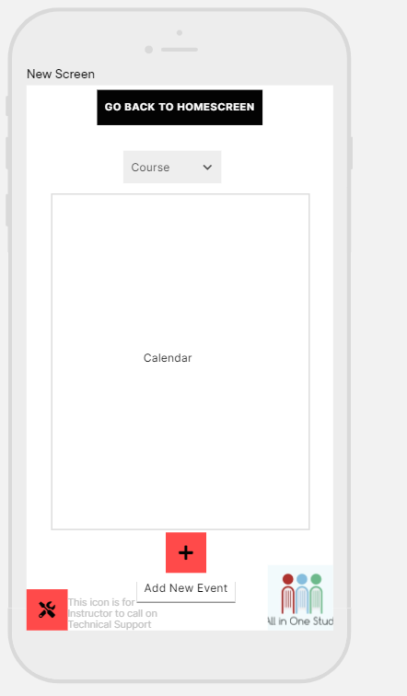

STEP 1: As an instructor once the Calendar option has been selected the user will be brought to the Calendar Screen.

STEP 2: The instructor can refer to the list of students in his or her course, so that he or she can publish schedules for all students in their courses to see what to complete for the current academic week

STEP 3: The instructor change or edit the calendar or even change the viewers of the calendar itself.

STEP 4: Once the instructor is done with what he or she needs to do, they can click the GO BACK TO HOME PAGE button and be directed to the main page for instructors.

STEP 5: The instructor can contact IT department if ever the need arises with resolving the issue over the app not working or causing an issue.

**Instructor Checklist Screen:**

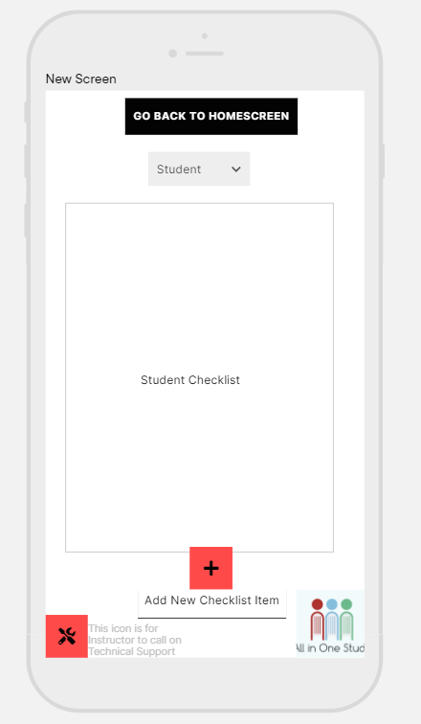

STEP 1: As an instructor once the Checklist option has been selected the user will be brought to the Checklist Screen.

STEP 2: The instructor can refer to the list of students in his or her course, once the student is selected it can show the checklists and their progress per student respectively.

STEP 3: The instructor can modify the checklists of students or even add new activities in the checklist section.

STEP 4: Once the instructor is done with what he or she needs to do, they can click the GO BACK TO HOME PAGE button and be directed to the main page for instructors.

**Instructor Grader Screen:**

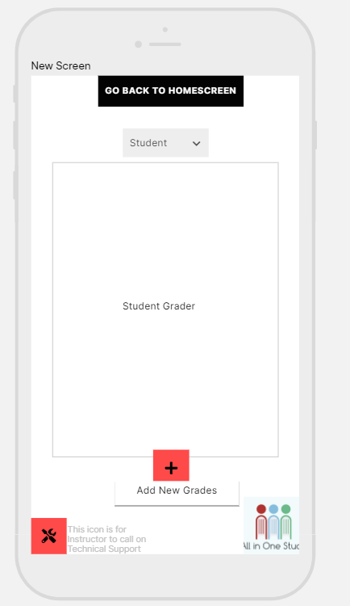’

STEP 1: As an instructor once the Grades option has been selected the user will be brought to the Grades Screen.

STEP 2: The instructor can refer to the list of students in his or her course, once the student is selected it show their grades prospectively.

STEP 3: The instructor can modify the grades of students or even add new activities in the grades section for record keeping purposes.

STEP 4: Once the instructor is done with what he or she needs to do, they can click the GO BACK TO HOME PAGE button and be directed to the main page for instructors.

**Administrator Home Screen**

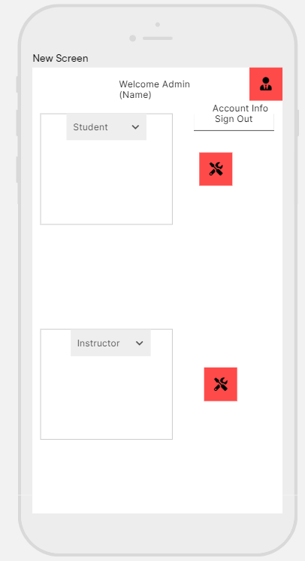

For accessing the information of students and Instructors, follow given steps:

STEP1: Click on the student option, then whole name list of all students will be observed and can send an email to any student with click on student name.

STEP2: By clicking on Instructor, User can see the names of all instructors and can communicate with a specific Instructor through email.

**Administrative Tools Screen**

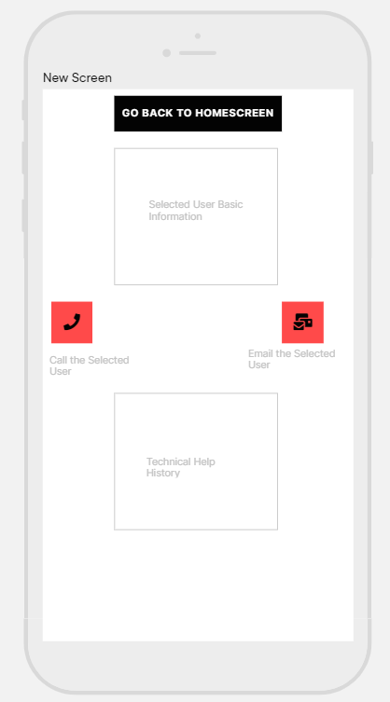

STEP 1: From either selected Student or Instructor option the admin can view their Account Info or the Technical Help History.

STEP 2: If the Admin wishes to contact the Student or Instructor to notify them of something or resolve an issue, they can click whether to use the Call option or Email option and either option will give them the contact details of the student or instructor

STEP 3: If the Admin wishes to go back to Home Screen, just click on the button on the top of the screen to proceed to main page.